**Spring REST using Spring Boot 3**

**Hands on 1 : Create a Spring Web Project using Maven**

**CODE:**

**SpringLearnApplication.java**

package com.cognizant.spring_learn;

import org.springframework.boot.SpringApplication;

import org.springframework.boot.autoconfigure.SpringBootApplication;

@SpringBootApplication

public class SpringLearnApplication {

public static void main(String[] args) {

System.out.println("Application starting...");

SpringApplication.run(SpringLearnApplication.class, args);

System.out.println("Application started.");

}

}  
  
**OUTPUT:**  
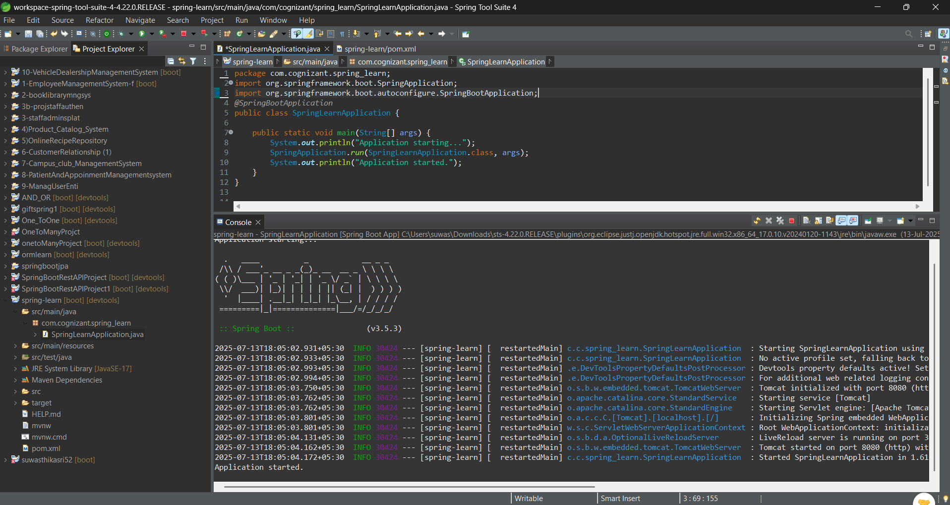

**HANDS ON 2 : Spring Core – Load Country from Spring Configuration XML**

**Country.java**

package com.cognizant.spring_learn;

import org.slf4j.Logger;

import org.slf4j.LoggerFactory;

public class Country {

private static final Logger LOGGER=LoggerFactory.getLogger(Country.class);

private String code;

private String name;

public Country() {

LOGGER.debug("Inside Country Constructor.");

}

public String getCode() {

LOGGER.debug("Inside getCode()");

return code;

}

public void setCode(String code) {

LOGGER.debug("Inside setCode()");

this.code = code;

}

public String getName() {

LOGGER.debug("Inside getName()");

return name;

}

public void setName(String name) {

LOGGER.debug("Inside setName()");

this.name = name;

}

@Override

public String toString() {

return "Country [code=" + code + ", name=" + name + "]";

} }

**SpringLearnApplication.java**

package com.cognizant.spring_learn;

import org.slf4j.Logger;

import org.slf4j.LoggerFactory;

import org.springframework.context.ApplicationContext;

import org.springframework.context.support.ClassPathXmlApplicationContext;

import org.springframework.boot.SpringApplication;

import org.springframework.boot.autoconfigure.SpringBootApplication;

@SpringBootApplication

public class SpringLearnApplication {

private static final Logger LOGGER = LoggerFactory.getLogger(SpringLearnApplication.class);

public static void main(String[] args) {

SpringApplication.run(SpringLearnApplication.class, args); // Start Spring Boot context

displayCountry();

}

public static void displayCountry() {

ApplicationContext context = new ClassPathXmlApplicationContext ("country.xml");

Country country = context.getBean("country", Country.class);

LOGGER.debug("Country : {}", country.toString());

System.out.println("Country: " + country); // add this for console verification

}

}

**Country.xml**  
<?xml version="1.0" encoding="UTF-8"?>

<beans xmlns="http://www.springframework.org/schema/beans"

xmlns:xsi="http://www.w3.org/2001/XMLSchema-instance"

xsi:schemaLocation="http://www.springframework.org/schema/beans

https://www.springframework.org/schema/beans/spring-beans.xsd">

<bean id="country" class="com.cognizant.spring_learn.Country">

<property name="code" value="IN" />

<property name="name" value="India" />

</bean>

</beans>

**Output:**

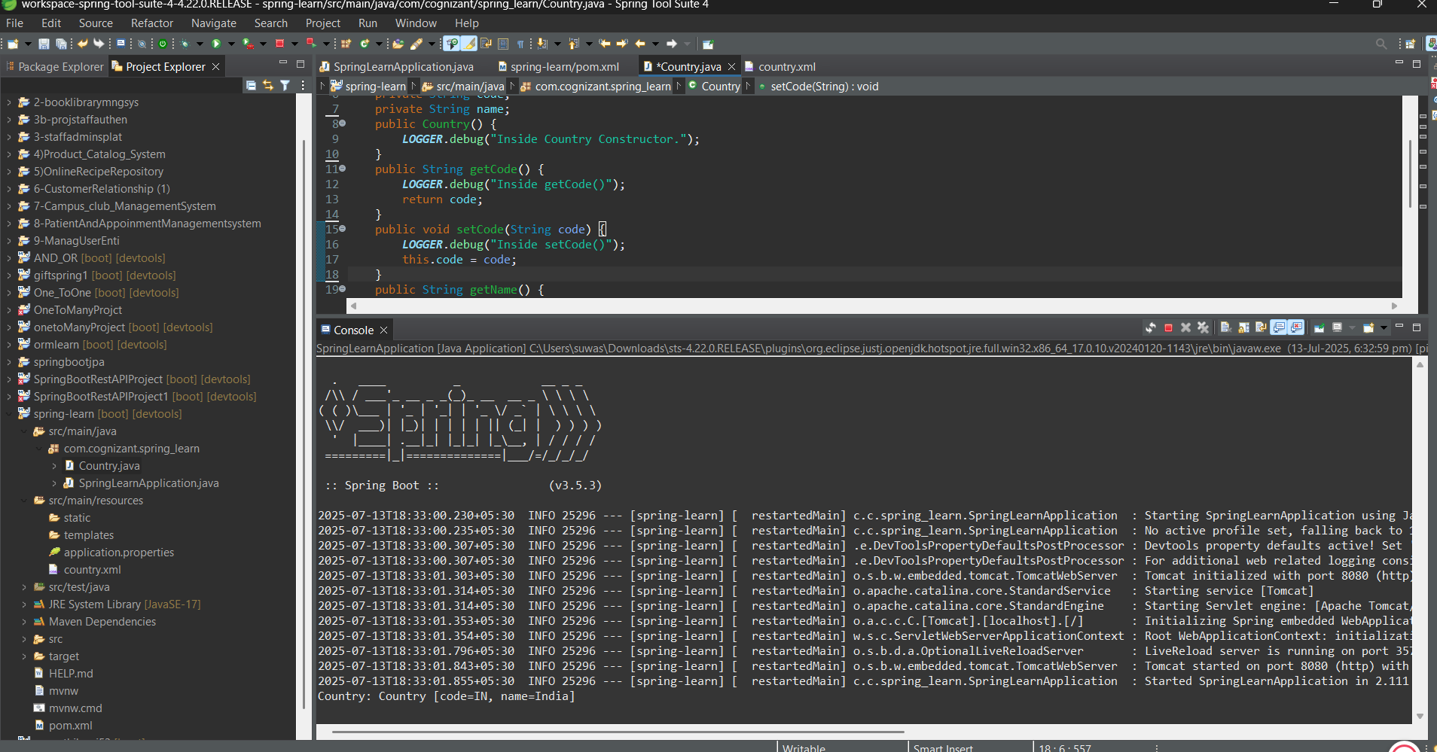

**Hands on 3: Hello World RESTful Web Service**

**Application.properties**

spring.application.name=spring-learn

**server.port=8083**

**postman**

URL: http://localhost:8083/hello

**Browser link**

<http://localhost:8083/hello>

**SpringLearnApplication.java**

@SpringBootApplication

public class SpringLearnApplication {

public static void main(String[] args) {

SpringApplication.run(SpringLearnApplication.class, args);

}

}

**HelloController.java**

package com.cognizant.spring_learn.controller;

import org.slf4j.Logger;

import org.slf4j.LoggerFactory;

import org.springframework.web.bind.annotation.GetMapping;

import org.springframework.web.bind.annotation.RestController;

@RestController

public class HelloController {

private static final Logger LOGGER = LoggerFactory.getLogger(HelloController.class);

@GetMapping("/hello")

public String sayHello() {

LOGGER.info("START sayHello()");

String message = "Hello World!!";

LOGGER.info("END sayHello()");

return message;

}

}

**OUTPUT:**

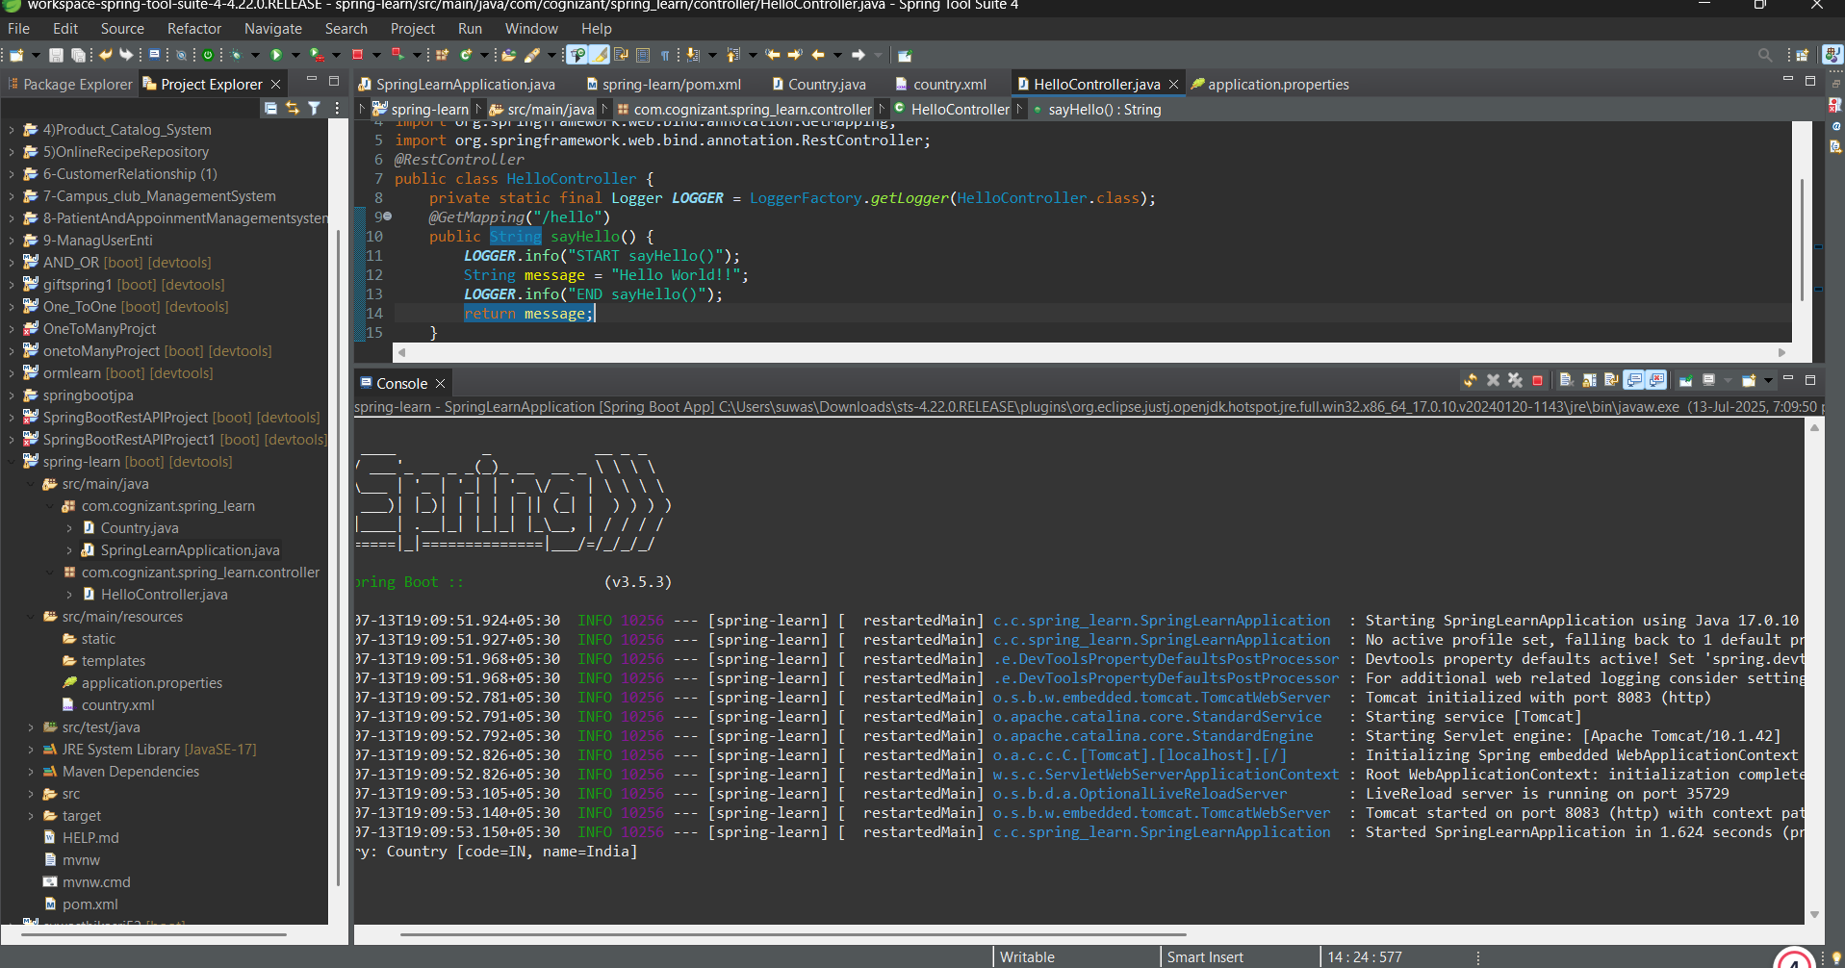

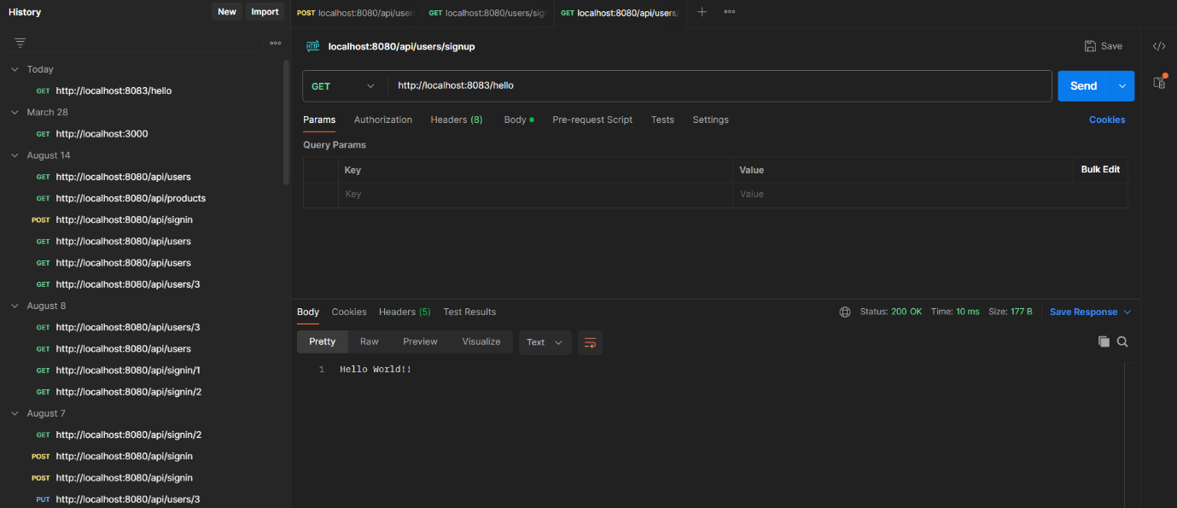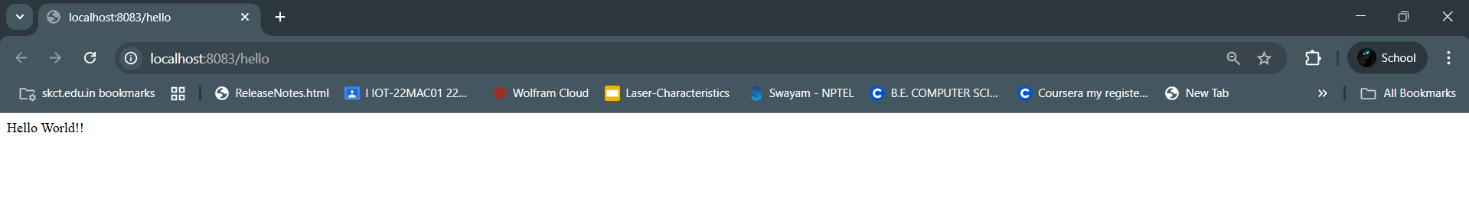

**Hands on 4 REST - Country Web Service**

**CountryController.java**

package com.cognizant.spring_learn.controller;

import com.cognizant.spring_learn.Country;

import org.slf4j.Logger;

import org.slf4j.LoggerFactory;

import org.springframework.context.ApplicationContext;

import org.springframework.context.support.ClassPathXmlApplicationContext;

import org.springframework.web.bind.annotation.RequestMapping;

import org.springframework.web.bind.annotation.RestController;

@RestController

public class CountryController {

private static final Logger LOGGER = LoggerFactory.getLogger(CountryController.class);

@RequestMapping("/country")

public Country getCountryIndia() {

LOGGER.info("START getCountryIndia()");

ApplicationContext context = new ClassPathXmlApplicationContext("country.xml");

Country country = context.getBean("country", Country.class);

LOGGER.info("END getCountryIndia()");

return country;

} }

**country.xml**

<bean id="country" class="com.cognizant.spring_learn.Country">

<property name="code" value="IN" />

<property name="name" value="India" />

</bean>

Postman

URL: <http://localhost:8083/country>

**OUTPUT:**

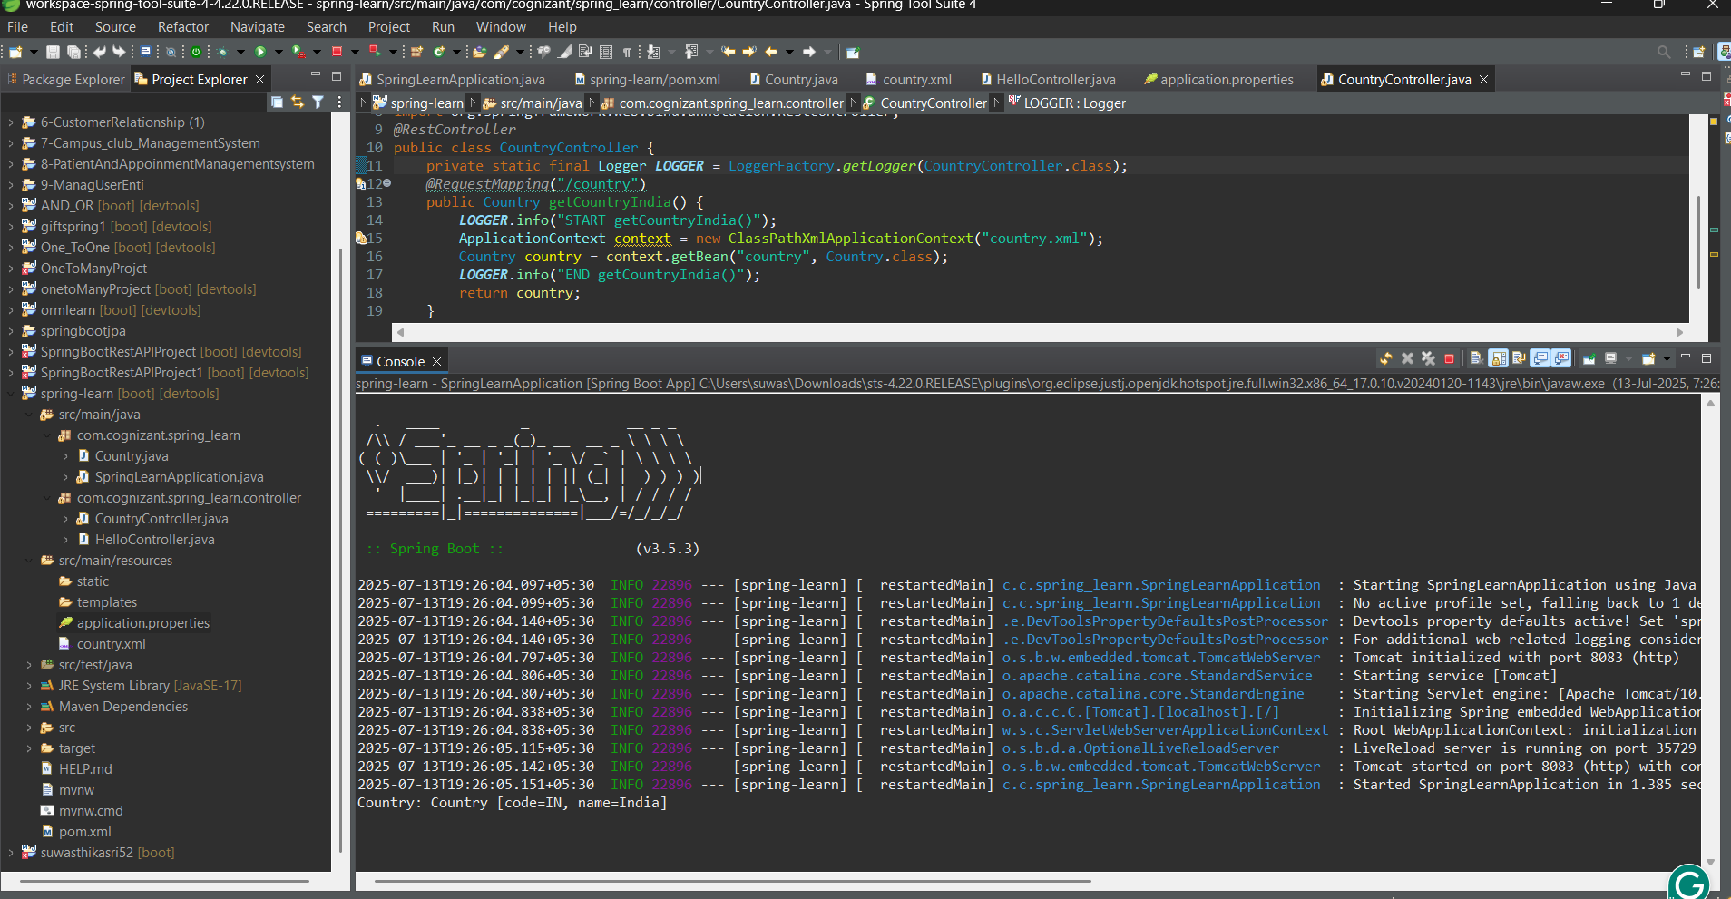

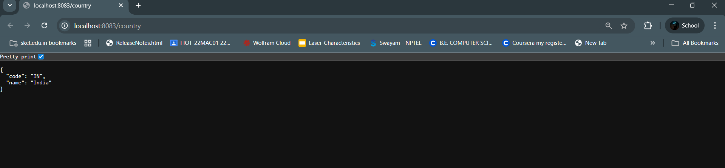

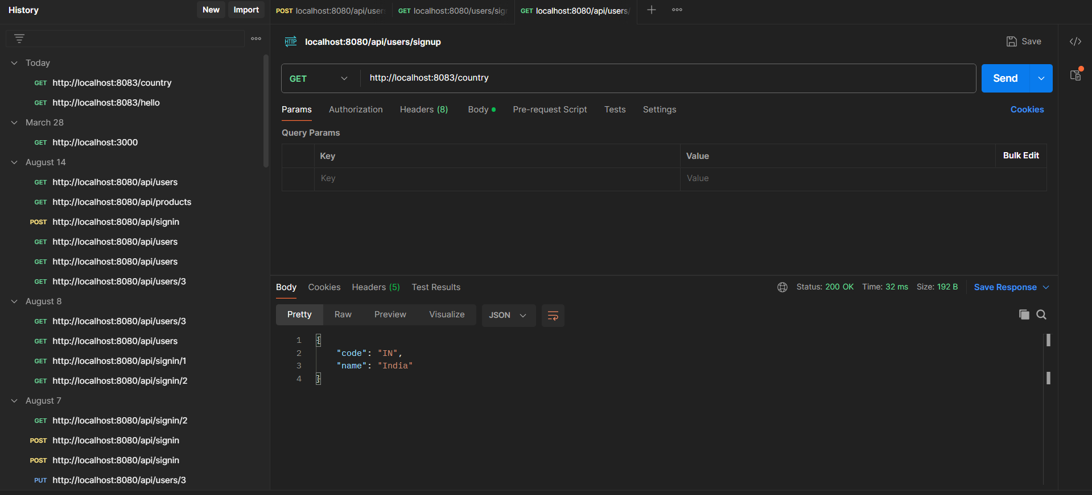

**Hands on 5 : REST - Get country based on country code**

**country.xml**<beans xmlns="http://www.springframework.org/schema/beans"

xmlns:xsi="http://www.w3.org/2001/XMLSchema-instance"

xsi:schemaLocation="http://www.springframework.org/schema/beans

https://www.springframework.org/schema/beans/spring-beans.xsd">

<bean id="country" class="com.cognizant.spring_learn.Country">

<property name="code" value="IN" />

<property name="name" value="India" />

</bean>

<bean id="countryList" class="java.util.ArrayList">

<constructor-arg>

<list>

<bean class="com.cognizant.spring_learn.Country">

<property name="code" value="IN" />

<property name="name" value="India" />

</bean>

<bean class="com.cognizant.spring_learn.Country">

<property name="code" value="US" />

<property name="name" value="United States" />

</bean>

<bean class="com.cognizant.spring_learn.Country">

<property name="code" value="JP" />

<property name="name" value="Japan" />

</bean>

<bean class="com.cognizant.spring_learn.Country">

<property name="code" value="DE" />

<property name="name" value="Germany" />

</bean>

</list>

</constructor-arg>

</bean>

</beans>

**CountryService.java**

package com.cognizant.spring_learn.service;

import com.cognizant.spring_learn.Country;

import org.slf4j.Logger;

import org.slf4j.LoggerFactory;

import org.springframework.context.ApplicationContext;

import org.springframework.context.support.ClassPathXmlApplicationContext;

import org.springframework.stereotype.Service;

import java.util.List;

@Service

public class CountryService {

private static final Logger LOGGER = LoggerFactory.getLogger(CountryService.class);

public Country getCountry(String code) {

LOGGER.info("START getCountry()");

ApplicationContext context = new ClassPathXmlApplicationContext("country.xml");

List<Country> countryList = (List<Country>) context.getBean("countryList");

Country result = countryList.stream()

.filter(c -> c.getCode().equalsIgnoreCase(code))

.findFirst()

.orElse(null);

LOGGER.info("END getCountry()");

return result;

}

}

**CountryController.java**

package com.cognizant.spring_learn.controller;

import com.cognizant.spring_learn.Country;

import com.cognizant.spring_learn.service.CountryService;

import org.slf4j.Logger;

import org.slf4j.LoggerFactory;

import org.springframework.beans.factory.annotation.Autowired;

import org.springframework.web.bind.annotation.*;

@RestController

public class CountryController {

private static final Logger LOGGER = LoggerFactory.getLogger(CountryController.class);

@Autowired

private CountryService countryService;

@GetMapping("/countries/{code}")

public Country getCountry(@PathVariable String code) {

LOGGER.info("START getCountry() with code: {}", code);

Country country = countryService.getCountry(code);

LOGGER.info("END getCountry()");

return country;

}

}

**OUTPUT**

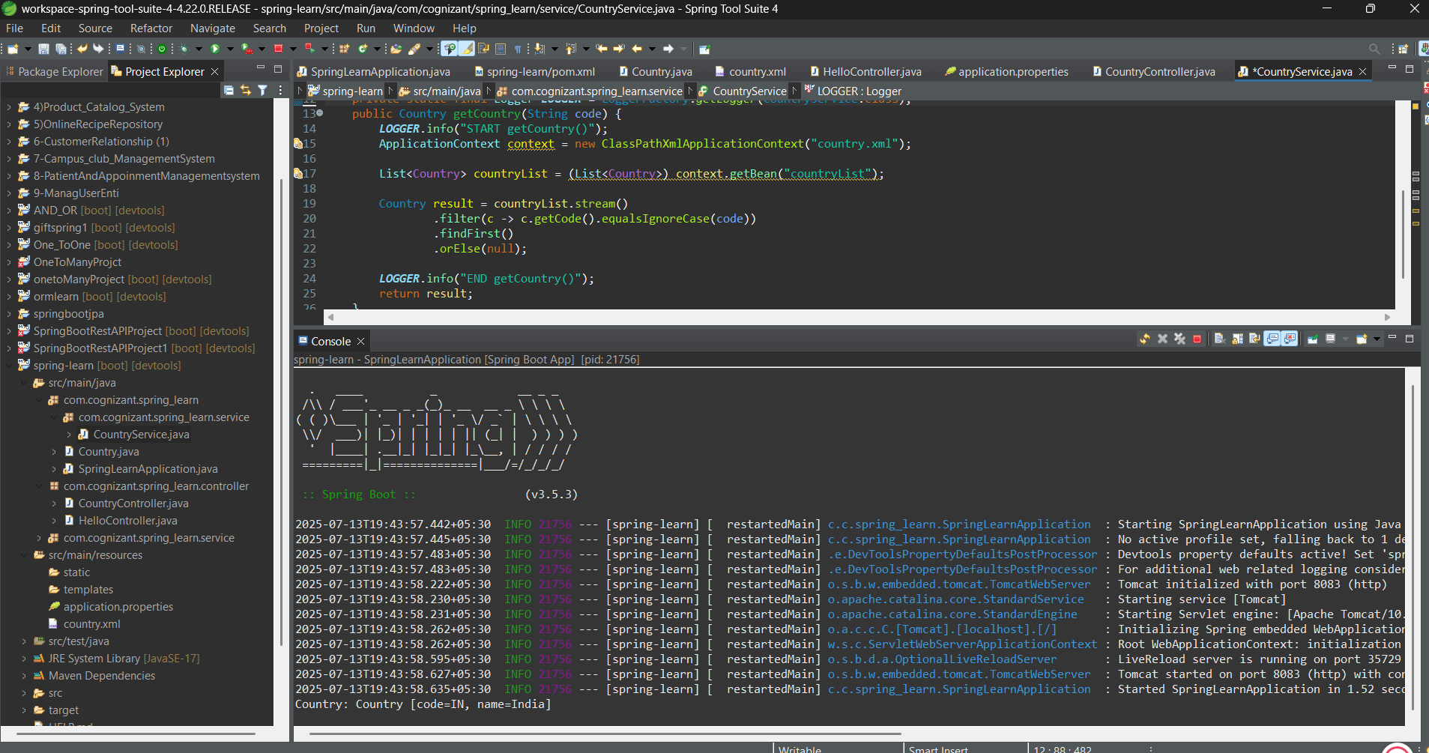

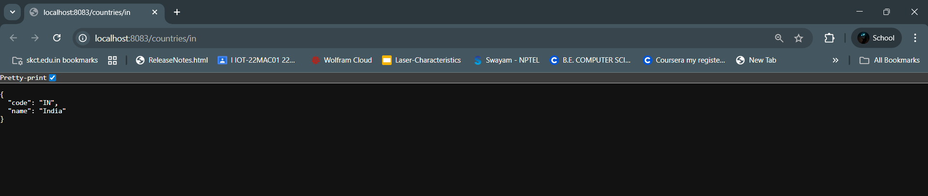

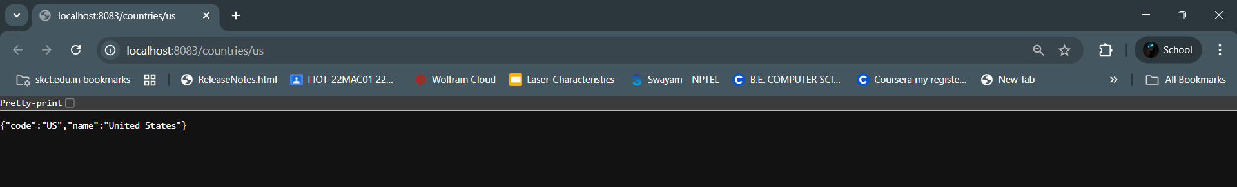

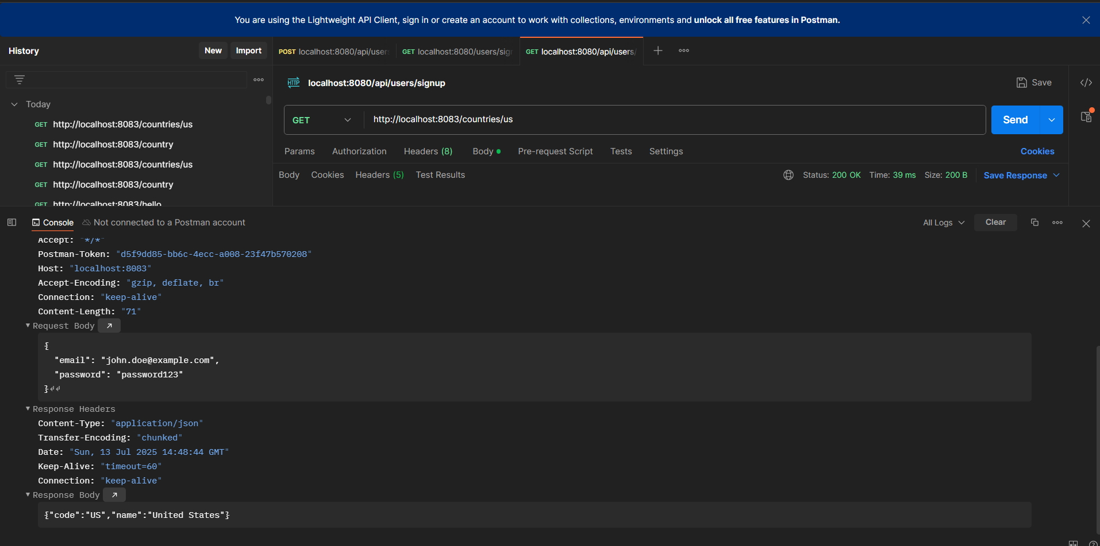

**Hands on 6 : Create authentication service that returns JWT**

**pom.xml**

<?xml version="1.0" encoding="UTF-8"?>

<project xmlns="http://maven.apache.org/POM/4.0.0"

xmlns:xsi="http://www.w3.org/2001/XMLSchema-instance"

xsi:schemaLocation="http://maven.apache.org/POM/4.0.0

https://maven.apache.org/xsd/maven-4.0.0.xsd">

<modelVersion>4.0.0</modelVersion>

<parent>

<groupId>org.springframework.boot</groupId>

<artifactId>spring-boot-starter-parent</artifactId>

<version>3.5.3</version>

<relativePath/> <!-- lookup parent from repository -->

</parent>

<groupId>com.cognizant</groupId>

<artifactId>spring-learn</artifactId>

<version>0.0.1-SNAPSHOT</version>

<name>spring-learn</name>

<description>Demo project for Spring Boot with JWT</description>

<properties>

<java.version>17</java.version>

</properties>

<dependencies>

<!-- Spring Web -->

<dependency>

<groupId>org.springframework.boot</groupId>

<artifactId>spring-boot-starter-web</artifactId>

</dependency>

<!-- Spring Security -->

<dependency>

<groupId>org.springframework.boot</groupId>

<artifactId>spring-boot-starter-security</artifactId>

</dependency>

<!-- JSON Web Token (JWT) -->

<dependency>

<groupId>io.jsonwebtoken</groupId>

<artifactId>jjwt-api</artifactId>

<version>0.11.5</version>

</dependency>

<dependency>

<groupId>io.jsonwebtoken</groupId>

<artifactId>jjwt-impl</artifactId>

<version>0.11.5</version>

<scope>runtime</scope>

</dependency>

<dependency>

<groupId>io.jsonwebtoken</groupId>

<artifactId>jjwt-jackson</artifactId>

<version>0.11.5</version>

<scope>runtime</scope>

</dependency>

<!-- Spring Boot DevTools -->

<dependency>

<groupId>org.springframework.boot</groupId>

<artifactId>spring-boot-devtools</artifactId>

<scope>runtime</scope>

<optional>true</optional>

</dependency>

<!-- Spring Boot Test -->

<dependency>

<groupId>org.springframework.boot</groupId>

<artifactId>spring-boot-starter-test</artifactId>

<scope>test</scope>

</dependency>

</dependencies>

<build>

<plugins>

<plugin>

<groupId>org.springframework.boot</groupId>

<artifactId>spring-boot-maven-plugin</artifactId>

</plugin>

</plugins>

</build>

</project>

**AuthenticationController.java**

package com.cognizant.spring_learn.controller;

import io.jsonwebtoken.Jwts;

import io.jsonwebtoken.SignatureAlgorithm;

import org.springframework.web.bind.annotation.GetMapping;

import org.springframework.web.bind.annotation.RestController;

import java.util.Date;

import java.util.HashMap;

import java.util.Map;

@RestController

public class AuthenticationController {

private static final String SECRET_KEY = "secret123";

@GetMapping("/authenticate")

public Map<String, String> authenticate() {

String jwt = Jwts.builder()

.setSubject("user") // ideally from authenticated user

.setIssuedAt(new Date())

.setExpiration(new Date(System.currentTimeMillis() + 1000 * 60 * 60))

.signWith(SignatureAlgorithm.HS256, SECRET_KEY.getBytes())

.compact();

Map<String, String> response = new HashMap<>();

response.put("token", jwt);

return response;

}

}

**SecurityConfig.java**

package com.cognizant.spring_learn.config;

import org.springframework.context.annotation.Bean;

import org.springframework.security.config.annotation.web.builders.HttpSecurity;

import org.springframework.security.web.SecurityFilterChain;

import org.springframework.context.annotation.Configuration;

@Configuration

public class SecurityConfig {

@Bean

public SecurityFilterChain filterChain(HttpSecurity http) throws Exception {

http

.csrf(csrf -> csrf.disable())

.authorizeHttpRequests(auth -> auth

.requestMatchers("/authenticate").authenticated()

.anyRequest().permitAll()

)

.httpBasic();

return http.build();

}

}

**OUTPUT:**

